34.44: a) 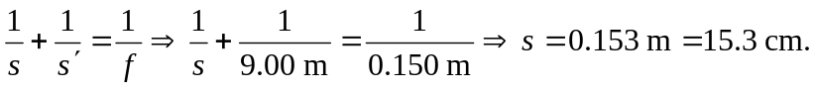
b) 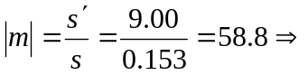dimensions are

